March 24, 2014
Weekly letter from Mrs. Hunt
Parents,
1. Please read the following important new items:Math/Science night is tomorrow, March 25, 2014 from 6:30pm to 7:30pm. The Pre-K through sixth grade will be teaching and presenting unique math strategies to parents. Parents are encouraged to visit several classroom during the evening. Students may wear nice free dress to school.
2. Caroline Basonga is improving daily. She is eating, speaking and able to move very slowly. Caroline is still very weak and being monitored closely. Her children are under excellent care and going about their daily schedule. Your thoughts and prayers must be working! Thank you for your generous offers of meals, play dates and transportation.
Please be so kind to make a contribution (any amount) for the Bambarate family. You may make a check to J. E. Cosgriff School. Please make sure you note on the check and/or attach a note with cash that your donation should be directed to the Bambarate Children.
The host family has requested very few meals for the Bambarate children. You will be asked by the school administration to provide a meal as needed. Thank you for your generous offers.
3. Congratulations to all seventh and eighth grade students who competed in the 2014 Salt Lake Valley Science and Engineering Fair. Nine of our students won an award with one special recognition award from the United States Navy. Six students have been invited to compete in the Broadcom MASTERS National Science Fair competition. Click on the following link SLVSEF 2014 awards to view the entire results as they are quite unbelievable!!
More students won 1st, 2nd or 3rd place from J.E.Cosgriff School than any other competing middle school in the state. In addition, Anna Shum, eighth grade student received the highest score in the junior division.
A word of sincere appreciation goes to Mr. Jim Larson for his inspiration and dedication to his science and math students. Our Cosgriff students are very fortunate to learn from a teacher/mentor each day who recognizes such strong potential in each one of them and then encourages them to work hard and aim for the stars. Congratulations Mr. Larson, you did it again!!!
4. Thank you to the students and parents who attended “Beauty Redefined” last week. A special note of thanks to Mrs. Monica Frederick for arranging such a timely and meaningful talk for our middle school girls.
5. Summer School 2014-Application packet click on the following link 2014 Summer Adventure Camp Packet. Summer school begins June 2, and ends on June 26. It is offered for pre-school up to and including eighth grade students. More explicit instruction in reading and math and tutoring will be available to students in addition to extended day from 12:00 noon to 4:00pm. Please read the brochure carefully for times, prices, weekly themes and special classes. Summer school is open to students who attend other schools and enrollment is on a first come first serve basis for all students. Sign up early for a space in the class of your choice. If you have questions or would like to request a scholarship, please call or email Mrs. Hunt. 801-486-6933, bhunt@cosgriff.org.
6. Please note: Spring Vacation –March 31 to April 4. All classes resume on April
7. The HSA will meet on Monday, April 7, at 7:00pm in the library.
8. Please note a very important in SCRIP pick up. Due to a very staggering increase of lost SCRIP (yellow bags), SCRIP CARDS WILL NO LONGER BE SENT HOME WITH YOUR CHILD. All cards will need to be picked up in the office or at the SCRIP table. Please watch for more detailed information concerning this change. Thank you for your cooperation in limiting the risk of loss for this important fundraising program.
9. J.E.Cosgriff School drama program presents “Seussical Jr,” a musical, celebrating the works of Dr. Seuss! Join us for two amazing performances in the St. Ambrose Church social center on Friday, April 11, at 7:00pm and Saturday, April, 12, at 2:30pm.
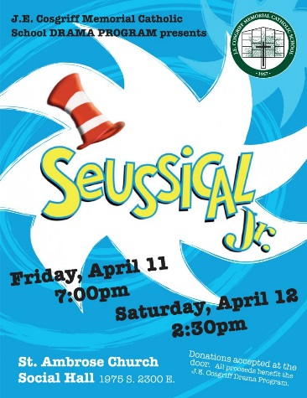
10. The Tiger Youth Track Club will start practice on April 14. Go to to http://cosgriff.org/students/sports/ to down load a registration form to be filled out and turned in the school office. A track schedule is also included.
Thank you
Betsy Hunt

