Parent News from Principal Mrs. Hunt, March 10, 2014
1. Please review the calendar of events below for the week of March 10 through 15, 2014

Wednesday – March 12, 2014
- School dismissal 3:15 p.m.
- Parent – Teacher Conferences – 3:45 p.m. – 7:00 p.m. (Extended Day as usual)
- No Homework Club

Thursday – March 13, 2014
- School dismissal 12:15 p.m.
- No school lunch on Thursday, March 13, 2014
- Parent – Teacher Conferences – 12:45 p.m. – 7:00 p.m.
- No Study Skills Class
- Extended day 12:15 – 6:00 p.m. and a.m. hours for Preschool and Pre-K

Friday – March 14, 2014
- NO SCHOOL
- Professional Development
Day for teachers
- Decorate the St. Patrick's Day Float

2. All parents should have an appointment for a Parent/Teacher Conference. It is very important that parents, teachers and students discuss current academic progress and goals for the fourth quarter of school, at the conferences. Go to http://www.signupgenius.com/go/10C0C44AAAD28A5F49-spring to sign up.
3. The St. Patrick’s Day Parade is Saturday, March 15, 2014, starting at 10:00 a.m. A very creative committee has decorated one float for the band and another one for other students and family. Thank you to parents and friends for constructing and decorating our St. Patrick’s Day floats. The floats are on display in the south faculty parking lot. Please wear your green sweat shirt or another clothing item which identifies you with Cosgriff School. The Marshalling area for floats is approximately 400 North and 200 West (our float number has not been issued as of 03/10/2014.) Parents please plan on marching the parade route with your children as it is difficult to reunite families at the end of the parade. The weather will be beautiful so come join in the fun and be Irish. – Even for a day!
4. Beauty Redefined, please join us for a very impactful presentation, March 20, 2014 7:00pm in the St. Ambrose Social Hall. Click on the image below for more information
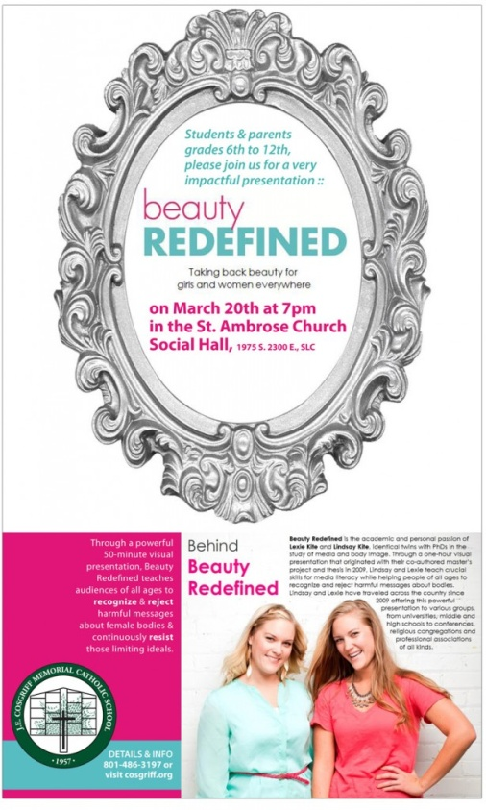
Thank you, Mrs. Hunt

