Monday News from Principal, Mrs. Hunt - January 6, 2014
Parents, Faculty, and Staff
Please read the following carefully.
*** Happy New Year and welcome back to the third quarter of the 2013-14 school year. January will be a very busy month for students, teachers and parents.
***Take time to review the uniform dress code, behavior and discipline, and consequences for tardiness and school absences in the Student Hand Book at the cosgriff.org web site.
***Note the following important dates and reminders:
January 9 - Reconciliation meeting, 7:00 p.m. (2nd grade parents only) (First choice) – Report cards will go home.
January 10 - All school mass 8:30 a.m. – Formal Dress – Announcement of honor roll students in the church immediately following mass.
January 12 – J. E. Cosgriff Open House 12:00 p.m. to 2:00 p.m. school library.
January 13 – HSA meeting, 7:00 p.m. school library.
January 15 – School Board meeting, 6:30 p.m. school library.
January 16 – Kindergarten Night, (parents only) 6:00 p.m. – 7:30 p.m. Click on the following link for more information Kindergarten Night Invite
Reconciliation meeting (Second choice)
January 20 – No School – Martin Luther King Day.
January 21 – No School – Professional Development Day for teachers.
January 23 – Reconciliation meeting (third choice) 2nd grade parents only.
January 25 – Spaghetti Dinner – School and Church Community, 6:00 p.m. Church Social Center.
January 26 - through January 31 – Catholic School’s Week
January 28 - Cosgriff Science Fair Awards Ceremony for students and parents 6:00 p.m. in the Social Center.
Cosgriff Open House 7:00 p.m. to 8:30 p.m. school library.
January 29 – Parent/Grandparent School and Science Fair visit 10:00-11:30 a.m. Parent/Grandparent Lunch 11:30 a.m. to 1:00 p.m. in Church Social Center.
January 30 – Progress Reports go home.
January 31 – First (1st) day of Cosgriff Ski Program. Click on the following link for more information http://cosgriff.org/students/extracurricular/
*Please contact Mrs. Hunt – Parents from Preschool through 8th Grade if you are available to help host one Cosgriff Open House.
January 12 – 12:00 p.m. to 2:00 p.m.
January 28 – 7:00 p.m. to 8:30 p.m.
Prospective parents have many questions for Cosgriff parents and faculty. Your assistance would greatly enhance the open houses. (Please contact Mrs. Hunt, bhunt@cosgriff.org or call 801-486-6933.)
***A ten week Study Skills Class will be offered to students grades 4 through 8 starting Thursday, January 16. Mrs. Anne Wiley will teach this important course. Scholarships are available based on financial need. Contact Mrs. Hunt. (bhunt@cosgriff.org) Please click on the following link for more information http://cosgriff.org/students/activities/
***The Christian Virtue which students will learn more about and discuss during January is Wisdom. Wisdom implies making good decisions as a mindful, well thought out process. Other virtues associated with wisdom are diligence, perseverance, reliability, and courage.
***The social skill which students will learn and practice in January is Reporting Behavior. (Teachers will be discussing the difference between reporting behavior and tattling. See below for more information:
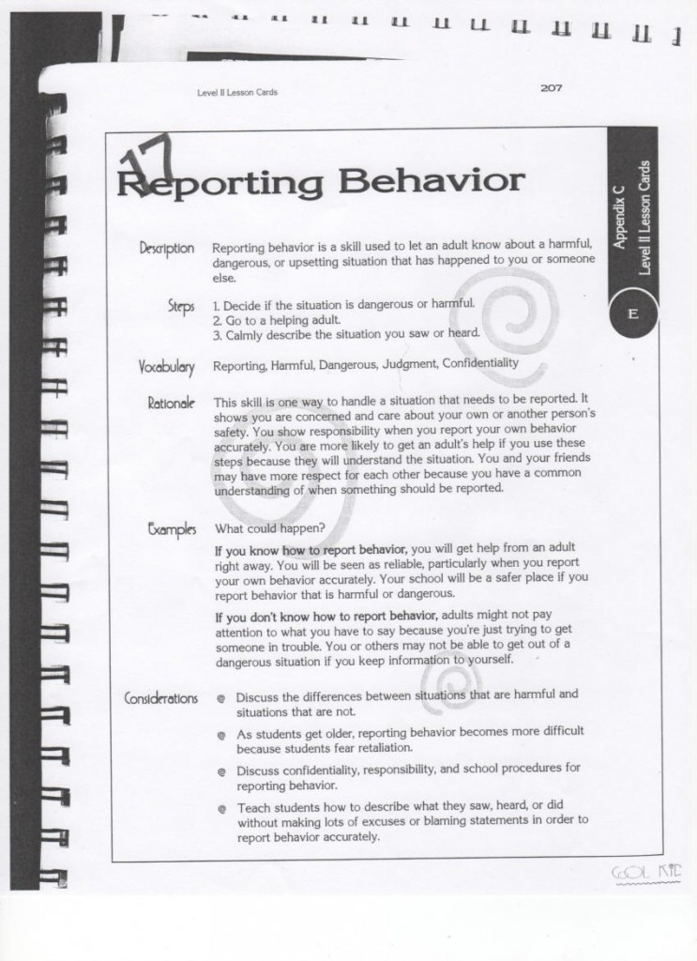
*** This is the second year the faculty has implemented a simple Bully Prevention Program in all grades. The basic components of the program are the following:
- STOP – A student uses the “Stop” signal if he/she is being teased, pushed, called a name, etc. The word Stop is said in a firm tone of voice.
- WALK – Sometimes when a student tells others to “Stop” problem behavior will continue. Students are encouraged to “walk away” from the problem behavior.
- TALK – When inappropriate behavior continues toward a student – he/she should TALK to an adult right away.
Please note the connection between Reporting Behavior and Tattling and the SimpleBullying Prevention program in place at Cosgriff School, as compared, to Tattling. Tattling is when a student does not use Stop, Walk, Talk, or fear he/she is in danger. The goal with tattling is to get someone else in trouble.
***Talk often with your child about the following:
- The Social Skill – Reporting Behavior.
- STOP, WALK, TALK – Bullying Prevention Program.
- The difference between reporting behavior and tattling.
***The January 2014 Student Council Service Project is the “Souper Bowl of Caring”. J. E. Cosgriff students and students from all other Catholic schools in Utah will work hard to collect healthy canned goods and money to help feed the hungry and homeless people of Utah. The Student Council will host several activities for this important purpose.
***Mark your calendar “SAVE the DATE” February 28, 2014. The 2014 Mardi Gras is Friday, February 28, 2014. Opportunity tickets will go home with your child next week. Please support our major Cosgriff fund raiser by purchasing a program ad, opportunity tickets or tickets for the event. Please donate an item for a class basket, live or silent auction item and most importantly your time for set up or working the event. Please watch for your invitation in the mail and plan on attending this exciting community event.
***We need your help for the Spaghetti Dinner, January 25, 2014 to assist with the set-up, kitchen prep, serving and clean-up. Please contact Michael Hilton if you are available to help. Email mchhilton@gmail.com and/or call 801-971-8370/cell or 801-484-6094/home to help with this event.
Thank you, Mrs. Hunt

