Principal’s Letter from: Mrs. Hunt, February 3, 2014
Please read the following:
1. HSA meeting tonight – 7:00 p.m. in the school library.
2. Class pictures will be taken tomorrow February 4, 2014. Formal dress is required.
3. Student progress reports will be available and sent home on Thursday, February 6. Discuss this report with your child and review his/her high academic goals for the third quarter of school.
4. Reminder: The class who sells the most Mardi Gras opportunity tickets by February 7 will receive an extra recess.
5. Thank you for your generous support of the “Souper Bowl” canned food and money collection. Approximately 1680 cans of food and $2000 were collected in January.
6. Save the Date: Parents of Preschool through Sixth Grade
Singapore Math Night
Date: Tuesday, February 11
Time: 7:00 p.m.
Location – Fifth grade classroom
Please come to learn and understand specific math strategies taught to your child. These strategies help strengthen the understanding of the common core math standards recommended in the State of Utah.
7. The Christian Virtue Cosgriff students will discuss, learn and practice during February is Love. We are asked to reach out in love to others as well as to love and respect ourselves. The virtue of love includes other qualities such as friendliness, cooperation, generosity, kindness,courtesy, and joyfulness. Please recognize these positive qualities in your own child.
The social skills which students will learn and practice during February are Giving a Compliment:
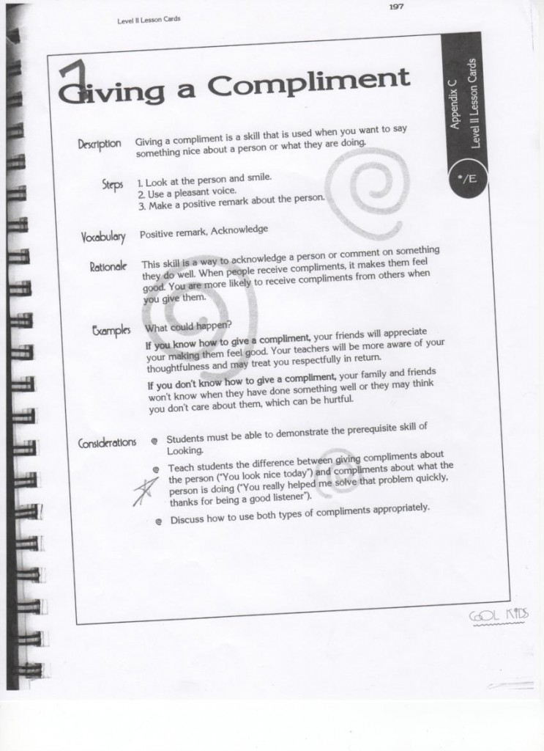
and volunteering
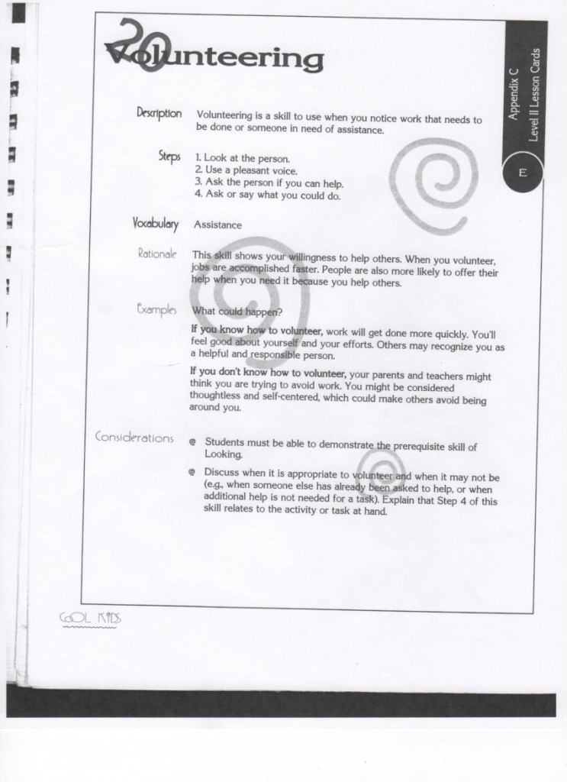
Both of these social skills line up closely with the Virtue of Love and Kindness.
8. The Student Leadership Council has selected “Shot through the Heart” as their service project for February. The purpose of this project is to help save the lives of children in the Quelessebougou commune and other rural areas around Mali, Africa. “Shot through the Heart” focuses on raising money for children to receive necessary vaccinations. It is a known fact that one out of five children in Mali do not live past their fifth birthday.
Cosgriff students will be asked to buy or sell a $2.00 Valentine which is the cost of vaccinating one child in Mali, Africa against nine diseases. The Student Council will also host a school raffle and sell heart suckers during the month to support this project.
9. Mardi Gras 2014 News!
Congratulations to Kindergarten, who sold the most Mardi Gras Opportunity Tickets last week! They won an extra computer class with Miss Brinkerhoff! This week, the class who sells the most tickets by Friday, Feb. 7 will receive an extra recess. Thank you for supporting this important fundraiser for our school.

Another way parents & grandparents can help with Mardi Gras is to purchase an ad in the Mardi Gras 2014 program guide. Please consider buying one for your business or for a special “Shout-Out” to your favorite student! Advertising details can be found at http://cosgriff.org/news-events/mardi-gras-2014/
We have more exciting Mardi Gras news coming tomorrow— A NEW opportunity drawing, online tickets sales & more!
10. Scout Sunday, February 9, 11:00 a.m. Mass. All Scouting members (Boy Scouts, Cubs, Girl/Junior Girl Scouts, and Daisy Scouts) are encouraged to attend that Mass in their scouting dress uniform as a way to show appreciation to the Parish and community for their support of these outstanding programs. Please arrive at 10:45 a.m. in the gathering space.
11. St. Ambrose Baseball Registration forms will be available in the school office, Monday, February 3, 2014.
Thank you, Mrs. Hunt

