April 7, 2014
Parent Letter from Mrs. Hunt,
Please read the following:
1. Home and School Meeting tonight, April 7, at 7:00pm in the Library.
2. Plan on attending our fabulous school play, “Seussical”. This delightful play will be performed April 11, at 7:00pm. Also, a Saturday matinee will be performed on April 12 at 2:30pm. Good luck to Mrs. Lacombe and her talented cast.
3. Please read the following important message from Monica Frederick, HSA President:
As we move towards the end of the school year, it is time to submit the remainder of your volunteer hours. All volunteer hours served previously or scheduled for the rest of the year, must be submitted through the school website by Thursday, April 17. Access the site through http://cosgriff.org/community-service/volunteer-cosgriff/
You will receive an invoice for any remaining hours with your registration materials and it will be payable on registration day. There are still some volunteer opportunities this year. Email Nikki Whye for more information (nwhye@cosgriff.org)
4. Our dear Mrs. Holly Dean has accepted a new and very challenging position at the University of Utah Reading Clinic starting July 2014, under the direction of Dr. Kathleen Brown. This will be an excellent opportunity for Mrs. Dean and a tremendous loss for J.E. Cosgriff School. Replacing Mrs. Dean will be a challenge to say the least. She will be greatly missed by ALL members of the faculty and staff as her academic wisdom, knowledge, teaching expertise and support have benefited literally every grade level for over ten years.
5. The Christian virtue which students will discuss and practice during the month of April is Self-Discipline. Self-Discipline includes self-restraint, self-reliance, and the ability to make a personal commitment and stick to it. Self–discipline makes one a “disciple” of oneself. A person must be his/her own teacher, trainer, coach and disciplinarian. We learn discipline through practice and hard work. As we near the end of the school year, it is important for students to practice self- discipline with their studies, choice of activities, and friendships. Encourage and support your child to focus and use self- discipline with the completion of academic requirements needed for a successful school year.
6. The social skill to talk to your child about is “Resisting Peer Pressure.” Click on image below to read more about this important skill. This social skill helps a person say “no” to a dangerous situation and also to say “no” to a computer game instead of studying for a math or science test. Self- Discipline and “Resisting Peer Pressure” are always a compliment to each other.
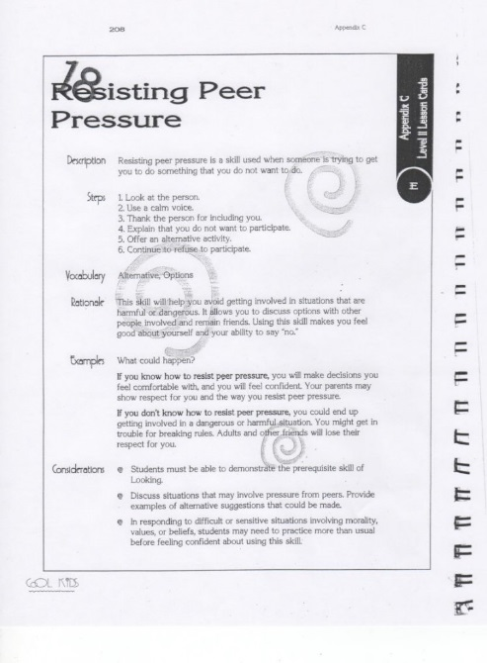
7. The 2014 Summer School packet with a detailed description of weekly themes, special support and extended day offerings is on the Cosgriff web page at http://cosgriff.org/students/summer-school-2014/. Review it and sign up right away in the school office. Questions about scholarships, and specific academic offerings, please call Mrs. Hunt. 801-486-6933.
8. The Student Leadership Council has chosen Neighbors Helping Neighbor (NHN) as the April community service project for Cosgriff School. The students wanted to support the elderly in our own city. The mission of NHN is to improve health, safety, and quality of life for community dwelling seniors through the promotion and maintenance of independent living. NHN strives to enable older adults to reside in the community for as long as possible. Students will take part in a raffle and free dress day in order to raise money for NHN. The money raised will help with home repairs, yard maintenance, food and clothing, and some medical expenses. Please go to NHN on the web site at http://www.socwk.utah.edu/neighbors/about.html to find out ways your own family can offer to volunteer for seniors in our community.
9. Caroline Basango is improving a little every day. She was recently moved from critical care to the next step up. She is weak, yet walks and is trying hard to get strong. Thank you for your prayers and support. Please continue to make a donation to the school in the family name. Their greatest need in the future will be financial.
10. Support Casey Bouillon, a current eighth grade student, at the April 26, 2014 MS walk in downtown Salt Lake City, Utah. Casey’s parents Rick and Lisa have invited everyone to participate at a level which they are comfortable. From his parents, “Your friendship and support are greatly!” Click on the following link to read more about Casey's story: http://main.nationalmssociety.org/site/TR/Walk/UTUWalkEvents?team_id=382530&pg=team&fr_id=23100
Thank you,
Betsy Hunt, Principal

