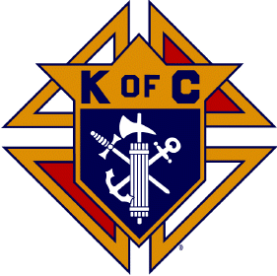Diocesan Science Fair Awards

**February 23, 2013**

**7th Grade:**

|  |  |
| --- | --- |
| Anna Shum | 1st Place Astronomy  Astronomy Recognition Award: Telescope |
| Leopoldine Viollet | 3rd Place Biological Science |
| Kate Kranz | 1st Place Engineering  Overall Engineering Science Award |
| Avery Young | 1st Place Environmental Science  Overall Environmental Science ward  7th Grade Honorable Mention Award (2nd Place Overall) |
| Emily Rougelot | 1st Place Medical/Behavioral Science |
| Siena DiSera | 2nd Place Medical/Behavioral Science |
| Zach Shubella | 1st Place Physical Science  Overall Physical Science Award  Overall 7th Grade ward  2013 Diocesan Young Scientist of the Year Award |
| Annie Trentman | 2nd Place Physical Science |
| Carter Holyoak | 3rd Place Physical Science |

**8th Grade:**

|  |  |
| --- | --- |
| Eugenie Viollet | 1st Place Biological Science  Overall Biological Science Award |
| Erin Morgan | 2nd Place Biological Science  Most Unique Visual Display Award |
| JD Villareal | 1st Place Engineering  Best Use of Working Model Award |
| Will Ryan | 1st Place Environmental Science |
| Ally Dowse  Cy Austin  Danny Brown | 1st Place Medical/Behavioral Science  Overall Medical/Behavioral Science Award  Overall 8th Grade Award  3rd Place Medical/Behavioral Science  1st Place Space and Aeronautics  Overall Space and Aeronautics Award |
|  |  |

**Other Highlights:**

* 232 projects at the fair
* 16 Cosgriff students placed
* 18 Cosgriff students advance to Salt Lake Valley Science and Engineering Fair